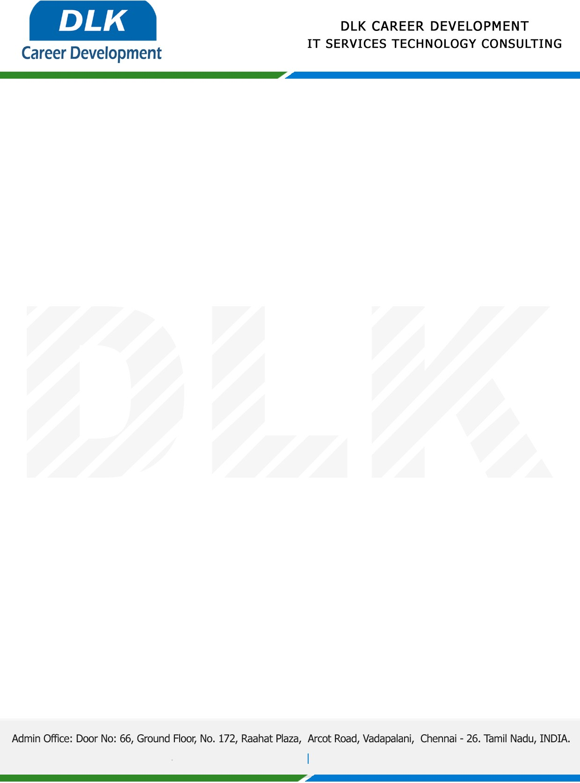

**Date: 19/ April /2023**

**SUB: PROJECT COMPLETION CERTIFICATE**

This is to certify that **MR SEENU V (REG NO:** **832100122) MSC- Computer Science,** final year student **Jaya College of Arts and Science, Chennai** has Successfully Completed the Project Work under the domain of “**Java”** in our organization during the Period **(15th January 2023 to 15th April 2023).**

**Topic:** E- Ration with QR Code Security.

We appreciate your interest in **DLK CAREER DEVELOPMENT**

**“Best Wishes for Your Future Endeavors “**

